InPlay Technologies, Inc.

13845 N. Northsight Blvd

Scottsdale, AZ 85260

U.S.A.
www.inplaytechnologies.com

Active Pen and Digitizer Human Input Devices

Digital (InPlay) vs. Analog (Others)

TABLE OF CONTENTS

Overview 3
1 Digital Approach 3
1.1 Theory 3
1.2 Architecture: 4
1.3 Grid Design 5
1.4 Intelligent Pen: 5
1.5 The Digital Advantage 6
1.6 InPlay’s Intellectual Property 6
2 Analog Approach 6
2.1 Architecture: 6
2.2 Theory 7
3 Comparison of Digital and Analog Architectures for Computing 9

Overview
In active pen and digitizer human input device (HID) solutions, data communication between the pen and the digitizer is based on either a) analog or b) digital communication.

1. Digital Approach

1.1 Theory
Digital communication involves using a single carrier frequency (such as 500 kHz), which is encoded with data to communicate information. The encoded information is transmitted in groups called digital “packets.” These packets can be used to communicate the pen position as well as detailed user input information. This mode of operation is based on PWM (Pulse Width Modulation) techniques in which information is divided into time slots.
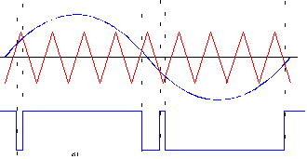

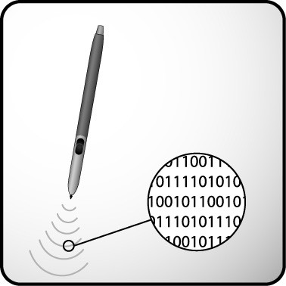

Fig 1: Pulse Width Modulation

Consider for example what is available to the digital phone user today, including voice, messaging, pictures and other services. This type of feature-rich capability was not available with the older analog cell phones.

1.2 Architecture:
InPlay Technologies uses an innovative digital architecture in its digitizer and pen design in which the digitizer circuitry processes the ON/OFF keyed pen signal through:

- Pre-Amplification - basic amplification to make the signal useable in the circuit.
- AGC - automatic gain control design to adaptively correct for varying pen signal strength.
- Bandpass Filtering – filtering designed to focus on the pen’s signal of interest and filter out everything else.
- Rectification - creation of a steady DC voltage exactly proportional to the pen’s signal strength.
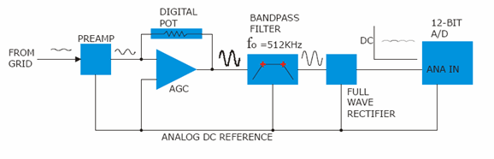
To uC
Fig 2. Digitizer Hardware Architecture (InPlay)

The rectified signal is in turn routed to a microcontroller which has an integrated 12 bit A/D converter operating at 1MHz.
In this case, system enhancements (such as added pen functions) are implemented in firmware without altering the basic hardware architecture. InPlay utilizes standard off-the-shelf ICs, as opposed to custom analog ASICs which must be redesigned even for small enhancements to the digitizer and pen functionality. This in turn results in the following benefits of the digital implementation:

- Quicker time to market
- Greater flexibility in choosing suppliers
- Lower costs

1.3 Grid Design
Another advantage of InPlay’s innovative technology is that the layout of a 2 layer digitizer uses 3 loops (see fig 3 below) :
- X-sensing loop : Senses x coordinates
- Y-sensing loop : Senses y coordinates
- Power loop : Charges the pen

The separate loops for charging and sensing make the InPlay’s digital solution more power efficient and less complex. This is in contrast to solutions offered by others which employ the same grid for charging the pen as well as sensing of the pen position.
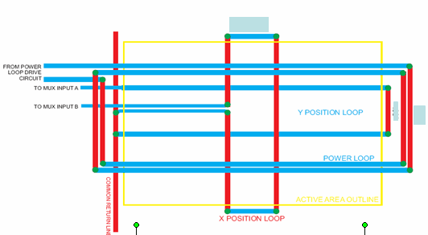
Fig 3: InPlay’s Digitizer Grid Design

1.4 Intelligent Pen
InPlay’s solution provides a pen with built-in intelligence. This is made possible with a microcontroller/ASIC inside the pen to enable communication with the digitizer. The microcontroller can be programmed to incorporate additional pen features based on future market and application requirements. One such example is a unique pen identification feature, whereby factory personnel will have different read and write access levels to the information on a computing device.
Other exiting pen solutions are solely based on a resonant circuit for communicating with the digitizer and hence can’t provide for integration of additional features such as pen identification in a cost effective manner. In addition, rather complex designs will be required.

1.5 The Digital Advantage
As with cell phones, digital communication has several inherent advantages for the pen computing market:
- Digital technology improves the communications between the PC and the pen and vice versa. It enables a wide range of feature enhancements to PC designer engineers, software applications and utility developers.
- The analogy is very similar to what the analog cell phones experienced prior to the proliferation of digital cell phones which enabled a much larger feature set.
- Unique pen identification, enables security.
- Ability to store information in the pen.
- Reconfigurable pens that will function as you desire them to.
- Multiple pens being used simultaneously.
The digital advantage means new and imaginative design features, previously prohibited
due to the limitations of analog circuitry and analog communication protocols, are now achievable.

1.6 InPlay’s Intellectual Property
- Firmware algorithms
- Touch controller
- Digitizer
- Digital pen features
- Design of the sensing and charging loops
- Signal filtering and processing

2. Analog Approach

2.1 Architecture:
InPlay's competitors primarily use an analog architecture which incorporates extensive analog filtering and hence has a high dependence on custom ASICs and can lead to higher cost.
In this case, the output from the digitizer (Fig. 4) is passed through multiple filter stages within a large footprint semiconductor IC. The state machine ultimately provides the digital bit stream to the USB /Serial interface. Since the design is based on a state machine a new version or new algorithms cannot be easily provided, in turn slowing down the time-to-market. Futhermore, any functional enhancements have to be done through making changes in the basic design/architecture of the ASIC (re-spin of IC) . The custom design of the ASIC also causes dependence on one supplier for the application specific development and an ultimately higher cost.

Multiple filter stages
Preamp

To USB
From digitizer

Fig 4: Architecture of Analog implementation

ASIC
multiple filtering stages
DIGITIZER
USB

Fig 5: Complex and bulky analog circuitry

2.2 Theory
Analog communication is based on the pen position signals being transmitted at a single center frequency (570 kHz for example), which is detected by the digitizer and translated into pen position data. This position information is sent to the host computer (PC). When the pen side button switch is pressed, circuitry in the pen ‘shifts’ the transmission frequency. The new frequency, such as 540 kHz in this example, communicates that the side button was depressed. The pen position is still being tracked at this new frequency. The digitizer communicates to the host PC that the pen side button is being pressed. When the tip switch is pressed onto the writing surface, the pen circuitry ‘shifts’ the frequency to a different frequency, such as 600 kHz. Consequently, data on variations in the pen tip pressure is communicated as incremental shifts in frequency in the range of 600 and 640 kHz. This mode of operation is based on frequency modulation.

Fig 6: Frequency Modulation

In this way the pen signals the digitizer, which translates certain frequencies into predetermined responses and communicates this to the host PC.

Fig 7: Analog Frequency Encoding

Note:
Please see the following table for comparison between analog and digital features for computing solutions:

3. Comparison of Digital and Analog Architectures for Computing

 | Digital | Analog
1. | Divides information up into time slots | Assigns a specific frequency band to each function and measures the frequency to determine what information is being transmitted from the pen
2. | Provides higher speed of operation and operates at lower voltages | Bandwidth limitations require a smaller frequency range as features are added; features that are available simultaneously result in geometric increase in the number of “frequency bins” required
3. | Requires less bandwidth improving the position signal fidelity (better accuracy and less jitter) | Smaller “frequency bins” require additional circuitry and fine tuning during assembly thus increasing the manufacturing cost
4. | Lower cost: Adding features does not require additional tuning or increase the cost of production | Adding features that require smaller frequency bins will result in incompatibility from other products with larger frequency bins. The net effect is that added features will reach a limit (Bandwidth limitation)

Disclaimer: Information in this document is provided in connection with InPlay products. No license, express or implied, by estoppel or otherwise to any intellectual property rights is granted by this document, except as provided in InPlay’s terms and conditions of sale for such products. InPlay assumes no liability whatsoever, and InPlay disclaims any express or implied warranty, relating to sale and/or use of InPlay products including liability or warranties relating to fitness for a particular purpose, merchantability or infringement of any patent, copyright or other intellectual property right. InPlay products are not intended in medical, life saving or life sustaining applications. InPlay may make changes to specifications and product descriptions at any time, without notice.

